DHBA NEWSLETTER
Oct/Nov 2020

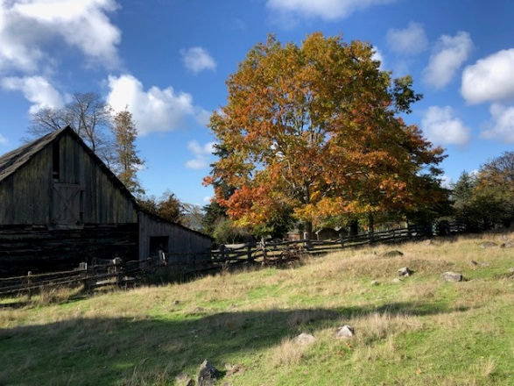
Notes from the BOT
As we close out 2020 we are grateful for the member's patience and all of the help we received this last year. We appreciate Shawn and Heather jumping to make it a seamless caretaker transition. It has been a long year and one of many challenges. The NASA space crew named their SpaceX shuttle "Resilience". This seems to be a good reflection of this last year and what we will need heading into the winter months.

Thank you to everyone that participated in the recent member meeting, member feedback requests, and member votes. The membership approved our 2020/21 annual budget and voted in a new BOT member this last week. We want to thank Stephanie Secord for 6 years of service and welcome Rich Mesher to the BOT. All recent documents and meeting notes have been uploaded to the website. They can be found on the Member Documents tab and a 2021 Calendar has been added.

We hope everyone stays safe and has a Happy Holidays.

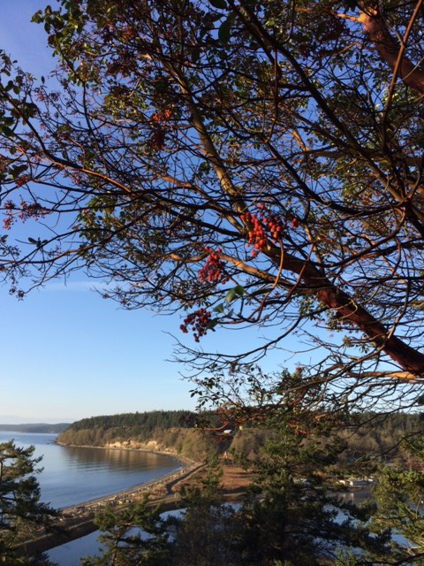
Notes From the Caretakers
Welcome to the first edition of the bimonthly DHBA newsletter. We will be composing a newsletter every other month to help keep the membership up to date on current projects and anything of interest at the Head and on Decatur Island.

Although it has been an unusual year, our first summer season at Decatur Head went smoothly, albeit too quickly as usual. As many of you know, the prime time calendar remained quite full through the season and has continued on into the fall. September’s visitation was up 175% from last year and October’s visitation was up 270%.

We have begun switching gears from summer to fall in preparation for the cooler temperatures and increased winds of winter. The fall colors have been beautiful and we are beginning to see migratory birds returning to enjoy the protected waters of the bay and lagoon.

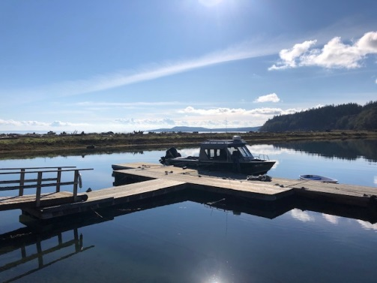
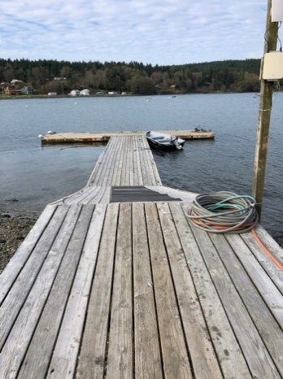
Maintenance Updates
Late October brought the first northeast gale and temperatures dipping down to the mid 30’s. Ahead of the storm, we shortened the dock for the season and moved Strait a’Head into the protection of the lagoon. We will keep an eye on the weather and how the dock handles in north wind blows. If need be, we will move all sections into the lagoon in order to preserve the condition of the dock.

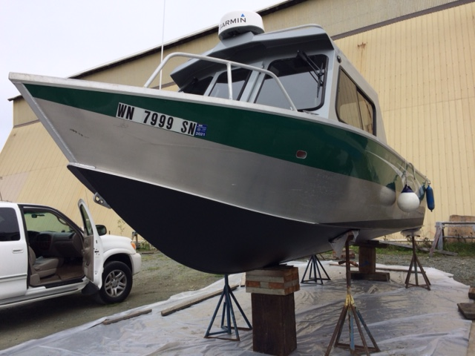
In October, Strait a’Head was hauled out at Skyline Marina and we scraped, sanded and applied two fresh coats of bottom paint on the hull. Depending on weather, we will likely trailer the boat in November and prep it for winter storage.

On October 22nd, all of the cabins’ septic systems were inspected by certified inspector, Kent Schaffer, who recommended six of the cabins have their scum layers pumped. Rainbow Septic arrived November 9th to perform the pumps. Kent and his wife Linda returned on November 11th to remove cabin 8’s old concrete septic tank lids in accordance with county regulations. They installed new riser adapters, risers and sealed lids on the septic tanks in three locations.

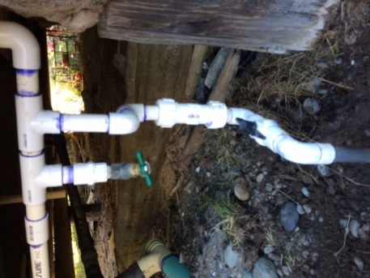
Over Halloween weekend we took advantage of the lull in visitation to shut the water down to cabins 4 through 8. We were able to fix a number of leaks and drips in faucets and pipes. With pipe winterization in mind for the coming cooler months, the BOT has decided to shut down cabins 5, 7 and 8 for the months of December, January and February. Cabins 7 and 8 are particularly vulnerable to freezing temps usually brought in from Fraser River outflows blowing from the north. Cabin 5 has exposed PVC pipes and suffered numerous breaks during the past winter. Plans for shutting down cabins 4 and 6 prior to January 2021 will be determined based visitation needs.

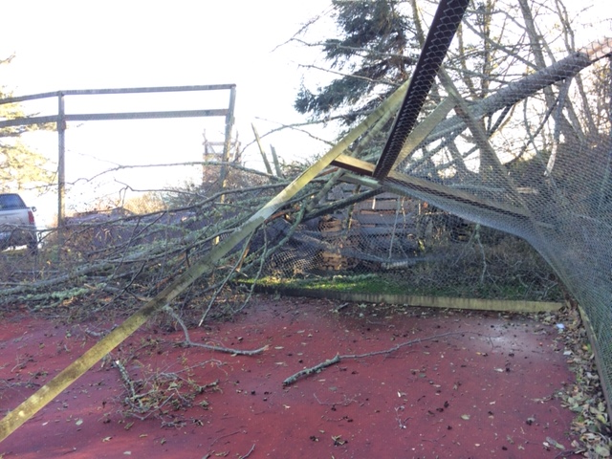
Beginning November 12th, back to back weather systems brought strong winds and gales from the southeast and west over a three day period. During these blows, the southwest corner of the sport court suffered damage from a fallen alder. We are working to clean the debris and assess the damage to the fencing. We have temporarily closed the court during these repairs.
.
Beginning around November 14th, we will be working with George Lamb to dredge the entrance of the lagoon. The permit allows us to take 250 cubic yards of material from specific areas around the entrance of the lagoon once every two to three years (as needed) for a period of ten years. The dredging must happen at a substantially low tide when the entrance is free of water. Unfortunately these low tides during the winter months typically coincide with times around midnight. George is equipped with high powered lights and a generator to illuminate the work zone.

After ten years of service, we will be retiring the office computer in early November with a new Dell Inspiron CPU. After replacing a failed power supply over the summer and running into issues with programs no longer running due to the computer’s older operating system, it was decided to upgrade the CPU. During the transition, there may be a slight delay in email responses as we shift files and programs over to the new computer.

For a full list of completed maintenance and repair projects happening at DHBA, please visit the Member Information tab on the Decatur Head website: https://www.decaturhead.org/updatesfaqs/

DHBA Tips
2020 has been an unprecedented year as we all try to cope with a world-wide pandemic. The remote nature of Decatur Head has proven to be a local, welcome escape from the more populated urban areas of the mainland. With temperatures and daylight hours changing, and the holidays approaching, please keep in mind social distancing practices, mask use, and flu shots. The following is a helpful, frank and honest article posted on the San Juan County website about socializing around the holidays and minimizing transmission risk: https://www.sanjuanco.com/DocumentCenter/View/21332/Hot-Topic-33-Holiday-Travel
And a new update from San Juan County regarding the recent increase in Covid-19 cases: https://www.sanjuanco.com/DocumentCenter/View/21394/201112-New-Cases-SJC

As the Head is experiencing higher than average visitation this season and combined with falling temperatures, electricity and firewood use is on the rise. To help with energy costs, please keep in mind efficient heater use – turn off all heaters when departing the cabins (unless otherwise advised) and close all windows and doors when the heaters are on. When building fires, save the split firewood for cabin use and small pieces of driftwood for the outdoor fire pits.

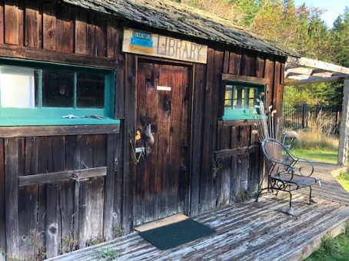
Decatur Island Updates
Over the summer, island volunteers renovated the historic cabin at the golf course and curated a wide selection of books for the new Decatur Island Library. This charming library has a book for every age and interest including a Decatur Island author section. The library has a self-checkout form for those looking to borrow books.

With fall in the air, the ever punctual Bufflehead ducks returned in late October. These migratory birds enjoy the protection and shallow foraging depths of the lagoon. We have counted over 25 of these small ducks diving, bobbing and splashing in the calm lagoon waters in the early evening hours. Harlequin ducks have also appeared off the south beach with the males in their full winter plumage.
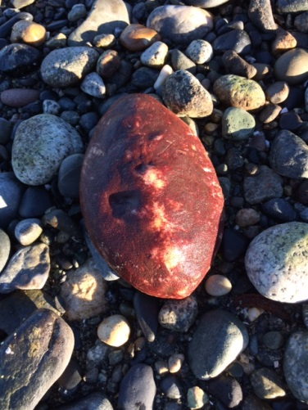
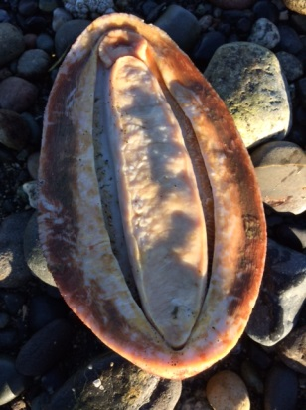
After the October northeast gale, we were fortunate to find a rare treasure while walking the beach north of the lagoon. A giant Pacific chiton, or gumboot chiton, had washed ashore. Nearly a foot in length, this prehistoric looking mollusk, had us stumped for a bit before we were able to ID the creature. We safely returned the chiton back to its saltwater home.

The following is the latest email update from the Decatur Island Community Emergency Resource Association (DICERA) to all property owners on Decatur Island (the emergency contact list mentioned at the bottom is attached and also printed in each cabin):
In late August, 16 additional persons attended the Wildlife Fire Training Course. The August training sessions were led by Jordan Pollock and Kyle Dodd, professional wildland firefighters and accredited trainers.
Between the July and August training sessions, 32 Islanders have gone through the Wildland Fire Training Course that provided firefighting theory and techniques based on industry standards. Combined, we achieved 144+ person hours of training, all within the COVID-19 health restrictions. This is a significant step forward in preparation and a key foundation from which to build.
TRAINED INDIVIDUALS : Deep gratitude and appreciation to all of you!
Four individuals were trained in Incident Response and Management which is critical in time of emergency response and are noted with an *.
Alan Fantel | Diana Foss | Mike Smith
Alan Mizuta | Gord Whitaker | Norine Jones
Amber Lewis | Heather Bansmer | Pat Gastineau
Andy Wood* | Jeff Christensen | Ramy Tipton
Arlene Frank | Jill Bliss | Randy Stricker
Beth Jones | Joe Severs | Richard Bevan
Bill Janes | Lee Wheeler | Rob Grant*
Brian Ross | Leif Edwards* | Saide Dupar
Chris Troutner | Mark Dupar* | Scott Phillippi
Dave Groff | Mark Wall | Shawn Breeding
Dennis Jenkins | Michelle Ross
Continued Training
To continue to be prepared, the trained group will continue to meet to further familiarize themselves with the operations of trucks, tanks, and practicing the skills learned in training sessions. Since the two initial sessions, there have been two follow up sessions; with others planned and led by some of these trained individuals. The commitment from these community members are so valued and appreciated.
Future Training
There are no further new training sessions planned for in 2020. Additional training needs will be assessed and a future session may take place in 2021. If you would like your name to be added to the list of those who would like to attend a training session, please respond to this email. Your name will be added.
Emergency Contact in Case of Fire Emergency
We are working directly with County Officials to develop:
- An emergency phone number that is specific to Decatur Island, but is not necessarily independent or mutually exclusive of existing SJC systems.
- A dispatch system
While this work is being done, follow the guidelines provided in the July Communication in case of Fire Emergency. The info will be shared again in a separate email.
Best to all of you, Alan Mizuta, Randy Stricker, Mark Wall, and Andy Wood

